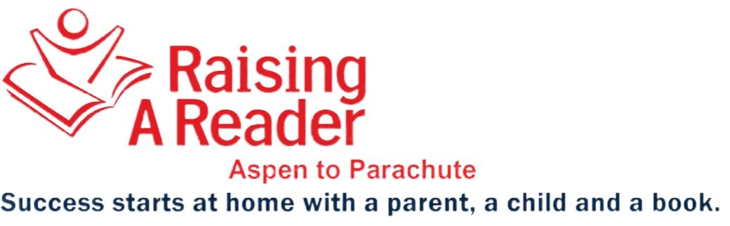

Rotating RAR’s Red Book Bags during Covid-19 Times
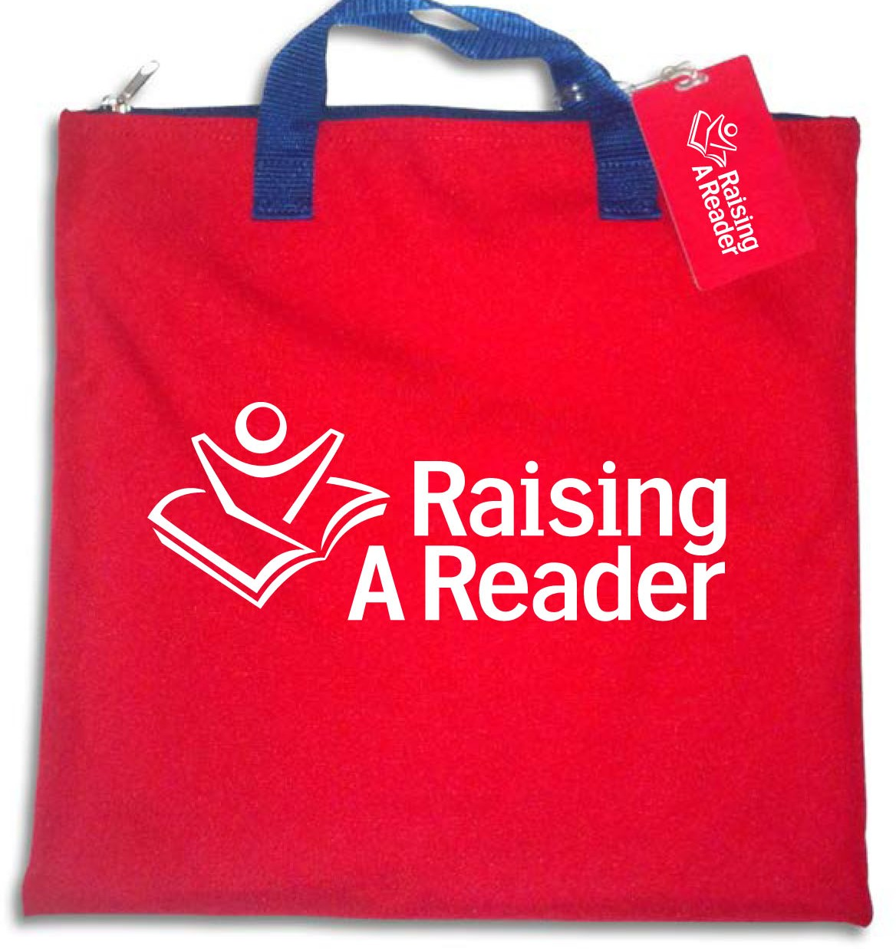

Per the CDC’s website:
Coronaviruses on surfaces and objects naturally die within hours to days. (1)

Children’s books, like other paper-based materials such as mail or envelopes, are not considered a high risk for transmission and do not need additional cleaning or disinfection procedures. (2)
RAR’s RECOMMENDATIONS FOR TEACHERS
4
HAND HYGENE
Make sure to always wash your hands/use hand sanitizer before and after you touch the bags, and before touching your face.
3
PREPARE FOR NEXT WEEK’S ROTATION
After seven days have passed, you can place the bags back into the “Borrow One” bin and keep them inside for next week’s rotation.
2
KEEP TWO RAR BINS
Ask your families to bring back their bags ON TIME and to place them inside your separate "Return" bin.
Keep them there for the next seven days.
1
SPACE THE BOOK BAG ROTATION
Hand out your red book bags and ask your families to keep them for TWO weeks.
- https://www.cdc.gov/coronavirus/2019-ncov/community/pdf/REopening_America_Guidance.pdf
- https://www.cdc.gov/coronavirus/2019-ncov/downloads/Guidance-for-Gen-Pop-Disaster-Shelters-COVID19.pdf

