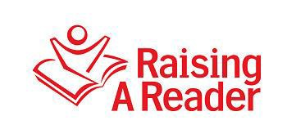

Commitment to Success!
Contract with Early Childhood Professionals

Raising A Reader® is committed to improving kindergarten readiness for low-income children not just today, but for years to come. Therefore we ask you, as an early childhood professional, to make a few commitments to Raising A Reader (RAR) before accepting the book bag kits. These commitments reinforce the value of the program and define you as an essential partner.

Raising A Reader’s effectiveness has been demonstrated in more than 20 independent evaluations and feedback from thousands of families. The initial cost of the program is about $115 per child– including materials and training. This is a meaningful resource to share with your children and caregivers.

During a Kickoff Orientation, we will teach you how to introduce the program to both children and their parents and how to manage the program over time. If the program is not managed well, there can be excessive damage or loss of books and book bags that in turn reduces the impact of the investments of financial resources and of staff time. When the program is run well – as shown by professionals using the program nationwide - then these materials serve parents and their children year after year. Refresher materials, shared annually with your site, will handle the normal rate of damage or loss.

Raising A Reader asks you, as an early childhood professional, to:

- Make the RAR program a central part of your curriculum. Share RAR books with children at school and they will share them with their families at home. Teach care of the materials so book bag kits last 5-7 years.
- Introduce the program to your children, families and staff as taught at your first implementer training, the Kickoff Orientation.
- Attend two RAR implementer trainings each year. Learn new strategies. Discuss relevant research.
4. Carefully manage the book bag check-out system and care of the books.
5. Offer at least two family literacy gatherings to develop caregivers’ book sharing skills.
6. Work with (Affiliate Name) to connect participating families to the library.
-------------------------------------------------------------------------------------------------------------------
In signing this contract, I commit my site to full partnership in the Raising A Reader Program.

Signature Name (please print) (date)

